First-Order Predicate Calculus (35 points)
a) Give one (1) predicate calculus representation for each of these English sentences. If you feel a sentence is ambiguous, provide a more detailed sentence that better captures the version represented by your FOPC. Choose reasonable constants, predicates and functions - the predicate dogs-chase-cats is not an acceptable answer to the first question.
i) Dogs chase cats.
ii) Some computers are cheap.
iii) Every book is valuable.
iv) Some chess pieces move diagonally, or my name isn’t Bobby Fischer.
v) All pianists and conductors know a piece written by Mozart.

i) John’s car is red.
ii) All of Wendt’s books are cataloged.
iii) Every player on [the sports teams] the Packers and the Brewers is rich.
iv) Every living thing likes Thanksgiving, except for the turkeys.
v) Unless it is a blizzard, Mary has some mode of transportation for getting to school.

b) For the English-FOPC pairs below, provide an interpretation that shows that the FOPC on the right does not represent the English on the left. Briefly explain your answers.
- All movie stars are envied. ∀X [ movie_star(X) ∧ envied(X) ]
- All children, when healthy like ice cream.
∀X [ child(X) → [ healthy(X) ∨ ¬likes(X,ice_cream) ] ]
- Some horses do not like hay. ∃x [ horse(x) → ¬likes(x, Hay) ]
- Bridge players who know all the rules are successful.
∀x,r [ { plays(x, Bridge) ∧ ruleOfBridge(r) ∧ knows(x, r) } → successful(x) ]

Deduction (30 points)
a) Use binary resolution to solve the problem below.
GIVEN:
(1) ∀X [ p(X) → q(X) ]
(2) ∀X [ p(X) → [ ∃ Y w(Y) ] ]
(3) ∀X ∀Y [ [ q(X) ∧ w(Y) ] → s(X) ]
(4) p(mary)
SHOW:
s(mary)
The givens in clausal form:
The negated query in clausal form:
The resolution proof:
b) Show how putting FOPC wff’s in clausal form and then doing binary resolution can produce the same new wff as the following natural deduction inference rules produce. You can show this by producing one concrete example, using P’s and Q’s, for each case; you do not have to show this for the general case.
i) modus tolens
ii) and elimination

Propositional Logic (15 points)
Part A. Use a truth table to show the following sentence in propositional logic is valid.
[(P → Q) ∧ (P → R) ] ↔ [P → (Q ∧ R)]
Part B. Let the following propositional symbols have the following meaning:
A John was in a car accident.
S John is sick.
I John is injured.
D John needs to see a doctor.

Express each of the following English sentences in propositional logic.
- John was in a car accident, but he isn’t injured.
- John needs to see a doctor if he is sick or injured.
- If John wasn’t in an accident and isn’t sick, then he doesn’t need a doctor.
- Mary’s father is married to Mary’s mother.

Express each of the following English sentences in FOL
- No human enjoys golf.
- All professors except historians write programs.
- Some professor that is not a historian writes programs.
- Every election has a winner.
- Only those trees that are tall have long roots.
- All birds can fly except for penguins and ostriches or unless they have a broken wing.
- There was a student in CS 540 Fall 1999 who was born in a country in South America.
- Unless the box currently on the conveyor belt is marked fragile, Robbie the robot will move it from the warehouse to the shipping dock.
- Cooking a pizza does not change its ingredients.
- John is the neighbor of Mary’s sister.
- To be a respected butterfly collector, one must possess two distinct and rare butterflies.
- Everyone on the team owes everyone else on the team an apology.
- Painting a block does not change its weight.
- At least one question on the CS540 final is hard.
- Whenever it snows in Madison, there is a slippery intersection somewhere in town.

Natural deduction proof
Using the inference rules for logic, complete the natural deduction proof below, whose task is to show that ∃x Z(x) follows from the givens. Be sure to justify your steps by stating the inference rule used, along with the previous line(s) to which it was applied.
# WFF Justification
1 P(1) given
2 W(1) ∧ W(2) ∧ W(3) given
3 ∀x [P(x) → ¬R(x)] given
4 ∀x [Q(x) ∨ R(x)] given
5 ∀x [ {Q(x) ∧ W(x)} → Z(x)] given

Given the well-formed formulae (wff’s) below, show that (S ∨ R) logically follows (don’t do more than 10 deductive steps):
WFF Justification
1 P given
2 (Q ∧ W) given
3 (P ∧ Q) ⇒ (S ∨ Z) given
4 (A ∨ R ∨ ¬ Z) given
5 ¬ A given

Formally show that S follows from the “given’s” below.
(Don’t deduce more than 10 additional WFF’s.)

Number WFF Justification
1 P ∧ Z given
2 (¬R ∧ ¬W) ∨ (¬P) given
3 (W ∧ Q) ⇒ P given
4 Q ∨ W given
5 Q ⇒ (S ∨ P) given
6 (P ∧ Q) ⇒ (S ∨ R) given

Formally show that S ∨ R follows from the “given’s” below.
(Don’t deduce more than 10 additional WFF’s.)

Number WFF Justification
1 ¬ (¬Q) ∧ Z given
2 ¬W given
3 (¬W ∧ Q) ⇒ (¬P) given
4 (W ∧ Z) ⇒ S given
5 Q ⇒ (S ∨ P) given
6 (P ∧ Q) ⇒ R given

Resolution Theorem Proving (14 points)
Consider the following formalization of a recent news story.
(1) Student 1 said that the University should construct more on-campus parking.
Student(S1) ∧ [ BuildsParkingLots(Univ) → ListenedTo(Univ, S1) ]
(2) Student 2 said that the University should not build more parking lots.
Student(S2) ∧ [ ¬BuildsParkingLots(Univ) → ListenedTo(Univ, S2) ]
(3) Student 3 said the University never listens to students.
∀x [ Student(x) → ¬ListenedTo(Univ, x) ]
Use resolution theorem proving to show that Student 3’s statement is false.
First, prepare and number your clauses.
Next, repeatedly apply the resolution inference rule.

PROBLEM 5 - Resolution Theorem Proving (15 points)
Consider the following statements.
Every man has his eyes checked by the doctor.
No man checks his own eyes.
Everyone is either a man or a woman.
Part A. Represent the English sentences above in FOPC.
Part B. Represent the above FOPC in clausal form.
Part C. Using resolution, show that the doctor is a woman.

2. (15 pts.) Logic
(a) (2) Translate into good, natural English (no xs and ys!):
∀x, y, l SpeaksLanguage(x, l) ∧ SpeaksLanguage(y, l)
→ Understands(x, y) ∧ Understands(y, x)
(b) (3) Translate into first-order logic the following sentences:
i. "If someone understands someone, then he is that someone's friend."
ii. "Friendship is transitive."
Remember to define all predicate, function, or constants and avoid the Long Predicate Names trap.
(c) (5) Suppose that Ann and Bob speak French and Bob and Cal speak German. Prove, using any first-order logical theorem-proving method you like, that Ann is Cal's friend, using as axioms the sentences from parts (a) and (b). Explain each step in detail, including any unifications required. You may abbreviate any symbols as necessary.
(d) (5) Give a formal proof that the sentence in (a) is entailed by the sentence
∀x, y, l SpeaksLanguage(x, l) ∧ SpeaksLanguage(y, l) → Understands(x, y)

Trả lời
(a) (2) A reasonable translation is, "If two people speak the same language then they understand each other."
One could quibble about whether this covers the case where x=y.
(b) (3) Understands(x, y) means that x understands y; Friend(x, y) means x is a friend of y.
i. ∀x, y Understands(x, y) ∧ Friend(x, y).
ii. ∀x, y, z Friend(x, y) ∧ Friend(y, z) → Friend(x, z)
(c) (5) Let the KB contain the following sentences, all Horn clauses:
A1: ∀x, y, l Speaks(x, l) ∧ Speaks(y, l) → Understands(x, y)
A2: ∀x, y, l Speaks(x, l) ∧ Speaks(y, l) → Understands(y, x)
B1: ∀x, y Understands(x, y) → Friend(x, y)
B2: ∀x, y, z Friend(x, y) ∧ Friend(y, z) → Friend(x, z)
C1: Speaks(Ann, French)
C2: Speaks(Bob, French)
C3: Speaks(Bob, German)
C4: Speaks(Cal, German)
We will prove Friend(Ann, Cal) using forward chaining.
- FC on A1, premises C1, C2, { x/Ann; y/Bob; l/French }, P1: Understands(Ann,Bob).
- FC on A1, premises C3, C4, { x/Bob; y/Cal; l/German }, P2: Understands(Bob,Cal).
- FC on B1, premise P1, { x/Ann; y/Bob }, P3: Friend(Ann,Bob).
- FC on B1, premise P2, { x/Bob; y/Cal }, P4: Friend(Bob,Cal).
- FC on B2, premises P3, P4, { x/Ann; y/Bob; z/Cal }, P5: Friend(Ann,Cal).

(d) (5) We need to show that D ⇒ A, i.e., D ∧ ¬A yields a contradiction. The CNF KB is
Q1: ¬S(x, l) ∨ ¬S(y, l) ∨ U(x, y)
Q2: S(A, F)
Q3: S(B, F)
Q4: (¬U(A, B) ∨ ¬U(B, A))
We will prove a contradiction using resolution:
- Resolving Q1, Q2, { x/A; l/F }, gives Q5: ¬S(y, F) ∨ U(A, y)
- Resolving Q5, Q3, { y/B }, gives Q6: U(A;B)
- Resolving Q1, Q2, { y/A; l/F }, gives Q7: ¬S(x, F) ∨ U(x, A)
- Resolving Q7, Q3, { x=B }, gives Q8: U(B, A)
- Resolving Q6, Q4, { }, gives Q9: ¬U(B, A)
- Resolving Q8, Q9, { }, gives the empty clause.

[40] Consider the sentence "Heads I win; tails you lose." Representing this sentence plus associated domain knowledge in FOPC, we have the following axioms (Me and You are constants, Win and Lose are predicates, and Heads and Tails are atoms):
1. Heads → Win (Me)
2. Tails → Lose (You)
3. ¬Heads → Tails
4. Lose (You) → Win (Me)
(a) [4] Convert these four wffs to clause form.
(b) [4] For each of the clauses in (a), specify if it is a Horn clause or not.
(c) [15] Construct a resolution refutation tree that proves that I win, i.e., Win (Me).
(d) [12] Instead of using resolution, say we want to prove Win (Me) using the goal reduction method with the same four rules given above. Show the complete goal reduction tree that is created when trying to prove this goal all possible ways.
(e) [5] From your result in (d), show either one subtree that proves the goal is solved (showing this by circling this subtree in your tree in (d)), or else explain why no solution is found.

Giải
(a) [4] Convert these four wffs to clause form.
¬Heads ∨ Win (Me)
¬Tails ∨ Lose (You)
Heads ∨ Tails
¬Lose (You) ∨ Win (Me)
(b) [4] For each of the clauses in (a), specify if it is a Horn clause or not.
All except for the third clause above are Horn clauses. The
third one is not because it contains two un-negated literals.
(c) [15] Construct a resolution refutation tree that proves that I win, i.e., Win (Me).
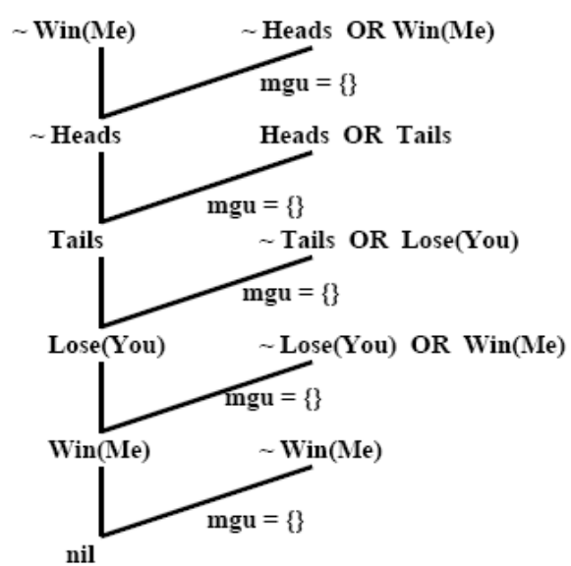
(d) [12] Instead of using resolution, say we want to prove Win (Me) using the goal reduction method with the same four rules given above. Show the complete goal reduction tree that is created when trying to prove this goal all possible ways.
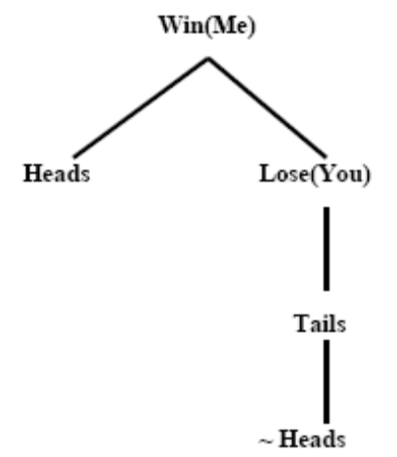
(e) [5] From your result in (d), show either one subtree that proves the goal is solved (showing this by circling this subtree in your tree in (d)), or else explain why no solution is found.
No solution is found because there are no "facts" that say,
e.g., that a given coin is currently "heads." Hence the
leafs in the tree in (d) are not known to be true and
therefore cannot be used to prove that the root goal is true.

[25] Suppose I have a problem represented in Propositional Logic using the atoms (called
propositional variables in the text) L, H, R, B and W:
L
H
L → R
(H ∧ R)→ B
(B ∧ H)→ W
(a) Use resolution refutation to construct a tree that proves W, if possible. If not possible, explain briefly why it can’t be done.
(b) Use goal reduction to construct an AND/OR tree that proves W, if possible. If not possible, explain briefly why it can’t be done.

Giải
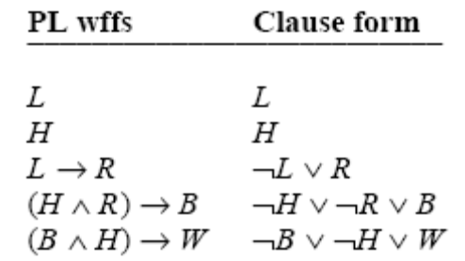
(a) Use resolution refutation to construct a tree that proves W, if possible. If not possible, explain briefly why it can’t be done.
1. ¬W axiom
2. ¬B ∨ ¬H ∨W axiom
3. ¬B ∨ ¬H RR(1,2)
4. H axiom
5. ¬B RR(3,4)
6. ¬H ∨ ¬R ∨ B axiom
7. ¬H ∨ ¬R RR(5,6)
8. H axiom
9. ¬R RR(7,8)
10. ¬L ∨ R axiom
11. ¬L RR(9,10)
12. L axiom
13. NIL RR(11,12)

(b) Use goal reduction to construct an AND/OR tree that proves W, if possible. If not possible, explain briefly why it can’t be done.
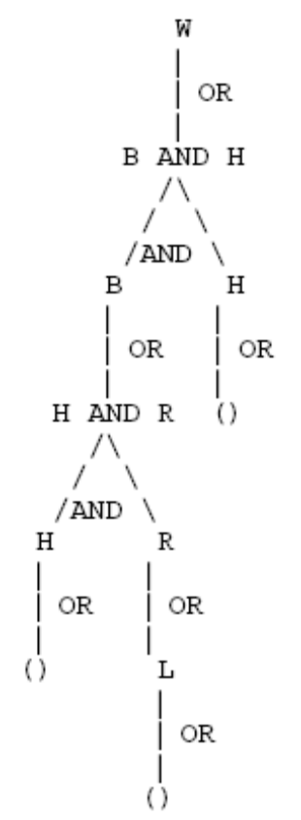

[20] Deductive Inference in Propositional Logic
You are given the following set of true sentences in Propositional Logic:
(i) A (vii) D => E
(ii) B (viii) D => F
(iii) C (ix) E => R
(iv) (A ∧ B) => D (x) G => R
(v) A => E (xi) (F ∧ C) => R
(vi) A => F (xii) (E ∧ F) => R
(a) [10] Use the Resolution Refutation algorithm to prove sentence R is true. Give your answer as a proof tree.
(b) [10] Give a Backward-Chaining proof that sentence R is true by constructing an AND-OR proof tree/graph.

[13] Representation in First-Order Logic
Consider the following function and predicate symbols:
Symbol name Type Meaning
mother(x) function returns the name of the person who is the mother of x
father(x) function returns the name of the person who is the father of x
female(x) predicate true if x is female
male(x) predicate true if x is male
sister(x,y) predicate true if x is the sister of y
brother(x,y) predicate true if x is the brother of y
Translate each of the following sentences into first-order logic (FOL).
(a) [4] Not everyone has a sister.
(b) [4] If one has a sister, the sister is female.
(c) [5] If one has the same mother and father as some person, then that person is either one’s brother or one’s sister.

[8] First-Order Logic and English Translation
For each of the following sentences in English, is the accompanying sentence in first-order logic a good translation? If yes, answer “yes.” If no, explain why not and then give a correct answer.
(a) [4] No two people have the same social security number.
¬∃x,y,n (IsPerson (x) ∧ IsPerson (y)) => (HasSS# (x,n) ∧ HasSS# (y,n))
(b) [4] Everyone’s social security number has nine digits.
∀x,n IsPerson (x) => (HasSS# (x,n) ∧ NumDigits (n, 9))

[8] (i) Using the three propositional symbols, J means "I get the job," H means "I work hard," and P means "I get promoted," convert the following English sentences into three sentences in Propositional Logic.
If I get the job and work hard, I will be promoted. I was not promoted. Thus, either I did not get the job or I did not work hard.
(J ∧ H)→P
¬P
¬J ∨ ¬H
(ii) Give an inference rule based on your sentences in (i) and then prove whether or not it is a sound rule of inference.
¬J ∨ ¬H
(J ∧ H)→P, ¬P
To prove soundness we must show that whenever the two
premises are true, the inferred sentence is also true. We
do this by constructing the truth table below, which shows
by the 4th, 6th, and 8th rows that yes, this inference rule
is sound.
J | H | P | J ∧ H | (J ∧ H)→ P | ¬P | ¬J ∨ ¬H
T | T | T | T | T | F | F
T | T | F | T | F | T | F
T | F | T | F | T | F | T
T | F | F | F | T | T | T
F | T | T | F | T | F | T
F | T | F | F | T | T | T
F | F | T | F | T | F | T
F | F | F | F | T | T | T
(d) [3] Is the following FOL sentence a tautology (aka valid), a contradiction (aka unsatisfiable), satisfiable, or none of these? Explain your answer using part or all of a truth table.
(A→ ¬B) → (C → B)
It is satisfiable (but not a tautology) as seen by two entries in the truth table: when A=true, B=true, and C=true, the
sentence is true, but when A=true, B=false, and C=true, the
sentence is false.

[8] First-Order Logic
For each of the following sentences in English, is the accompanying FOL sentence a good translation? If your answer is no, explain why not and correct it.
(a) [4] "Any course in Computer Science is harder than some courses in Psychology."
∀x (Course (x) ∧ Dept (x,CS))→ ∃y ((Course (y) ∧ Dept (y,Psychology))→ Harder (x,y))
No, with ∃ use ∧, not →. The correct version is
∀x (Course (x) ∧ Dept (x,CS))→ ∃y ((Course (y) ∧ Dept (y,Psychology)) ∧ Harder (x,y))
(b) [4] "If a course is harder than all courses in Math, it must be in Computer Science."
∀x Course (x) ∧ (∀y Course (y) ∧ Dept (y,Math) ∧ Harder (x,y))→ Dept (x,CS)
No, with ∀ use →, not ∧, so correct version is
∀x Course (x) ∧ (∀y Course (y) ∧ Dept (y,Math)→ Harder (x,y))→ Dept (x,CS)

